Eric Wilson

Springboard

July 2020

Guided Capstone Project Report - Big Mountain Resort

An analysis has been conducted regarding how Big Mountain Resort can leverage the installation of an additional chair lift and increase revenue over the upcoming year, offsetting the corresponding increase in operational costs. In this analysis, 27 attributes of 330 ski resorts across the country were considered, with a particular focus placed on the adult weekend fare that Big Mountain Resort is charging. Currently, the resort employs a fare structure that includes identical pricing for adults on weekdays and during the weekend. This is a pricing structure that is utilized by many resorts around the country. However, Big Mountain exhibits many advantages over other resorts with regard to features offered to customers; this may position the resort to be able to take greater advantage of the increased demand during the weekend and charge a higher fare. Thus, a classification and regression analysis was conducted to reveal where Big Mountain Resort stands relative to its peers and determine whether its pricing scheme is appropriate.

Characteristics such as summit elevation and vertical drop vary quite widely among the numerous resorts in this study. To take this into consideration, an additional feature was considered that describes the classification of resorts with respect to summit elevation and vertical drop. The results of the classification procedure are shown in Figure 1. As seen in this figure, Big Mountain Resort is a member of the

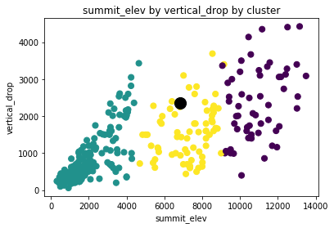

**Figure 1.** Cluster analysis of resorts in the study. The large black dot indicates Bear Mountain resort, residing in the yellow cluster.

middle cluster, characterized by moderate elevations and vertical drops from the summit. In this cluster, the vertical drop at Big Mountain is among the highest, which is clearly a positive feature for the resort. In fact, Big Mountain well exceeds the average of its peer group in a variety of areas, as shown in Table 1. This experience offered to customers commands a higher weekday fare as well as a higher premium for the more popular weekend period.

**Table 1**. Key characteristics of Big Mountain Resort and the averages for the yellow cluster

Name Runs SkiableTerrain fastQuads total chairs vertical_drop

Big Mountain Resort 105.000000 3000.000000 3.000000 14.000000 2353.000000 cluster average 45.326968 929.549296 0.943662 7.056338 1562.197183

To determine the optimal pricing as a function of resort attributes, a multiple linear regression study was performed. In this analysis, the state attribute was converted to a set of boolean variables, increasing the number of variables considered by approximately a factor of two. After the elimination of outliers and some highly correlated variables, a model was obtained that yielded a suggested adult weekend fare of $89.92. Figure 2 shows that this fare is above the weekday=weekend price line

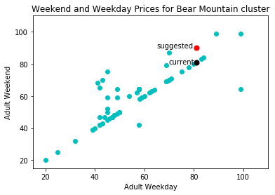

**Figure 2.** Weekend fares vs. weekday fares for the yellow cluster of Figure 1, containing Bear Mountain Resort. The black dot indicates current pricing for Bear Mountain, and the red dot indicates the resort’s suggested pricing.

depicting many of the resorts in the Big Mountain Resort cluster but is still well within the maximum weekend premium present among the resort’s market peers. This is more illustratively exhibited in Figure 3, which considers all resorts in the study. Here, the suggested ~10% weekend premium, indicated by the weekend/weekday ratio, is commonly applied among resorts with similar and greater vertical drops.

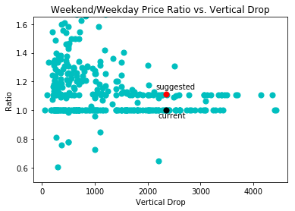

**Figure 3.** Adult weekend to adult weekday price ratio vs. vertical drop for resorts in the study. The black dot indicates the Bear Mountain current ratio, and the red dot indicates the resort’s suggested ratio.

In conclusion, a classification and regression analysis has revealed that the optimal price for the adult weekend fare at Big Mountain Resort is $89.92, an increase of approximately 10% over the current adult weekday and weekend prices. This increase will allow the resort to fully utilize the features it offers, including the newly implemented chair lift, to increase revenue and maintain its profit margin.